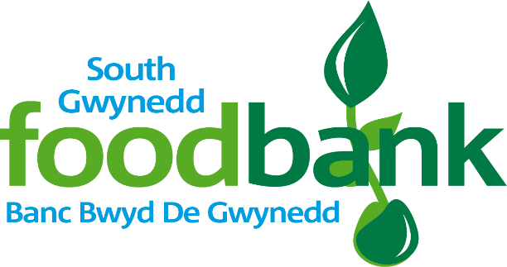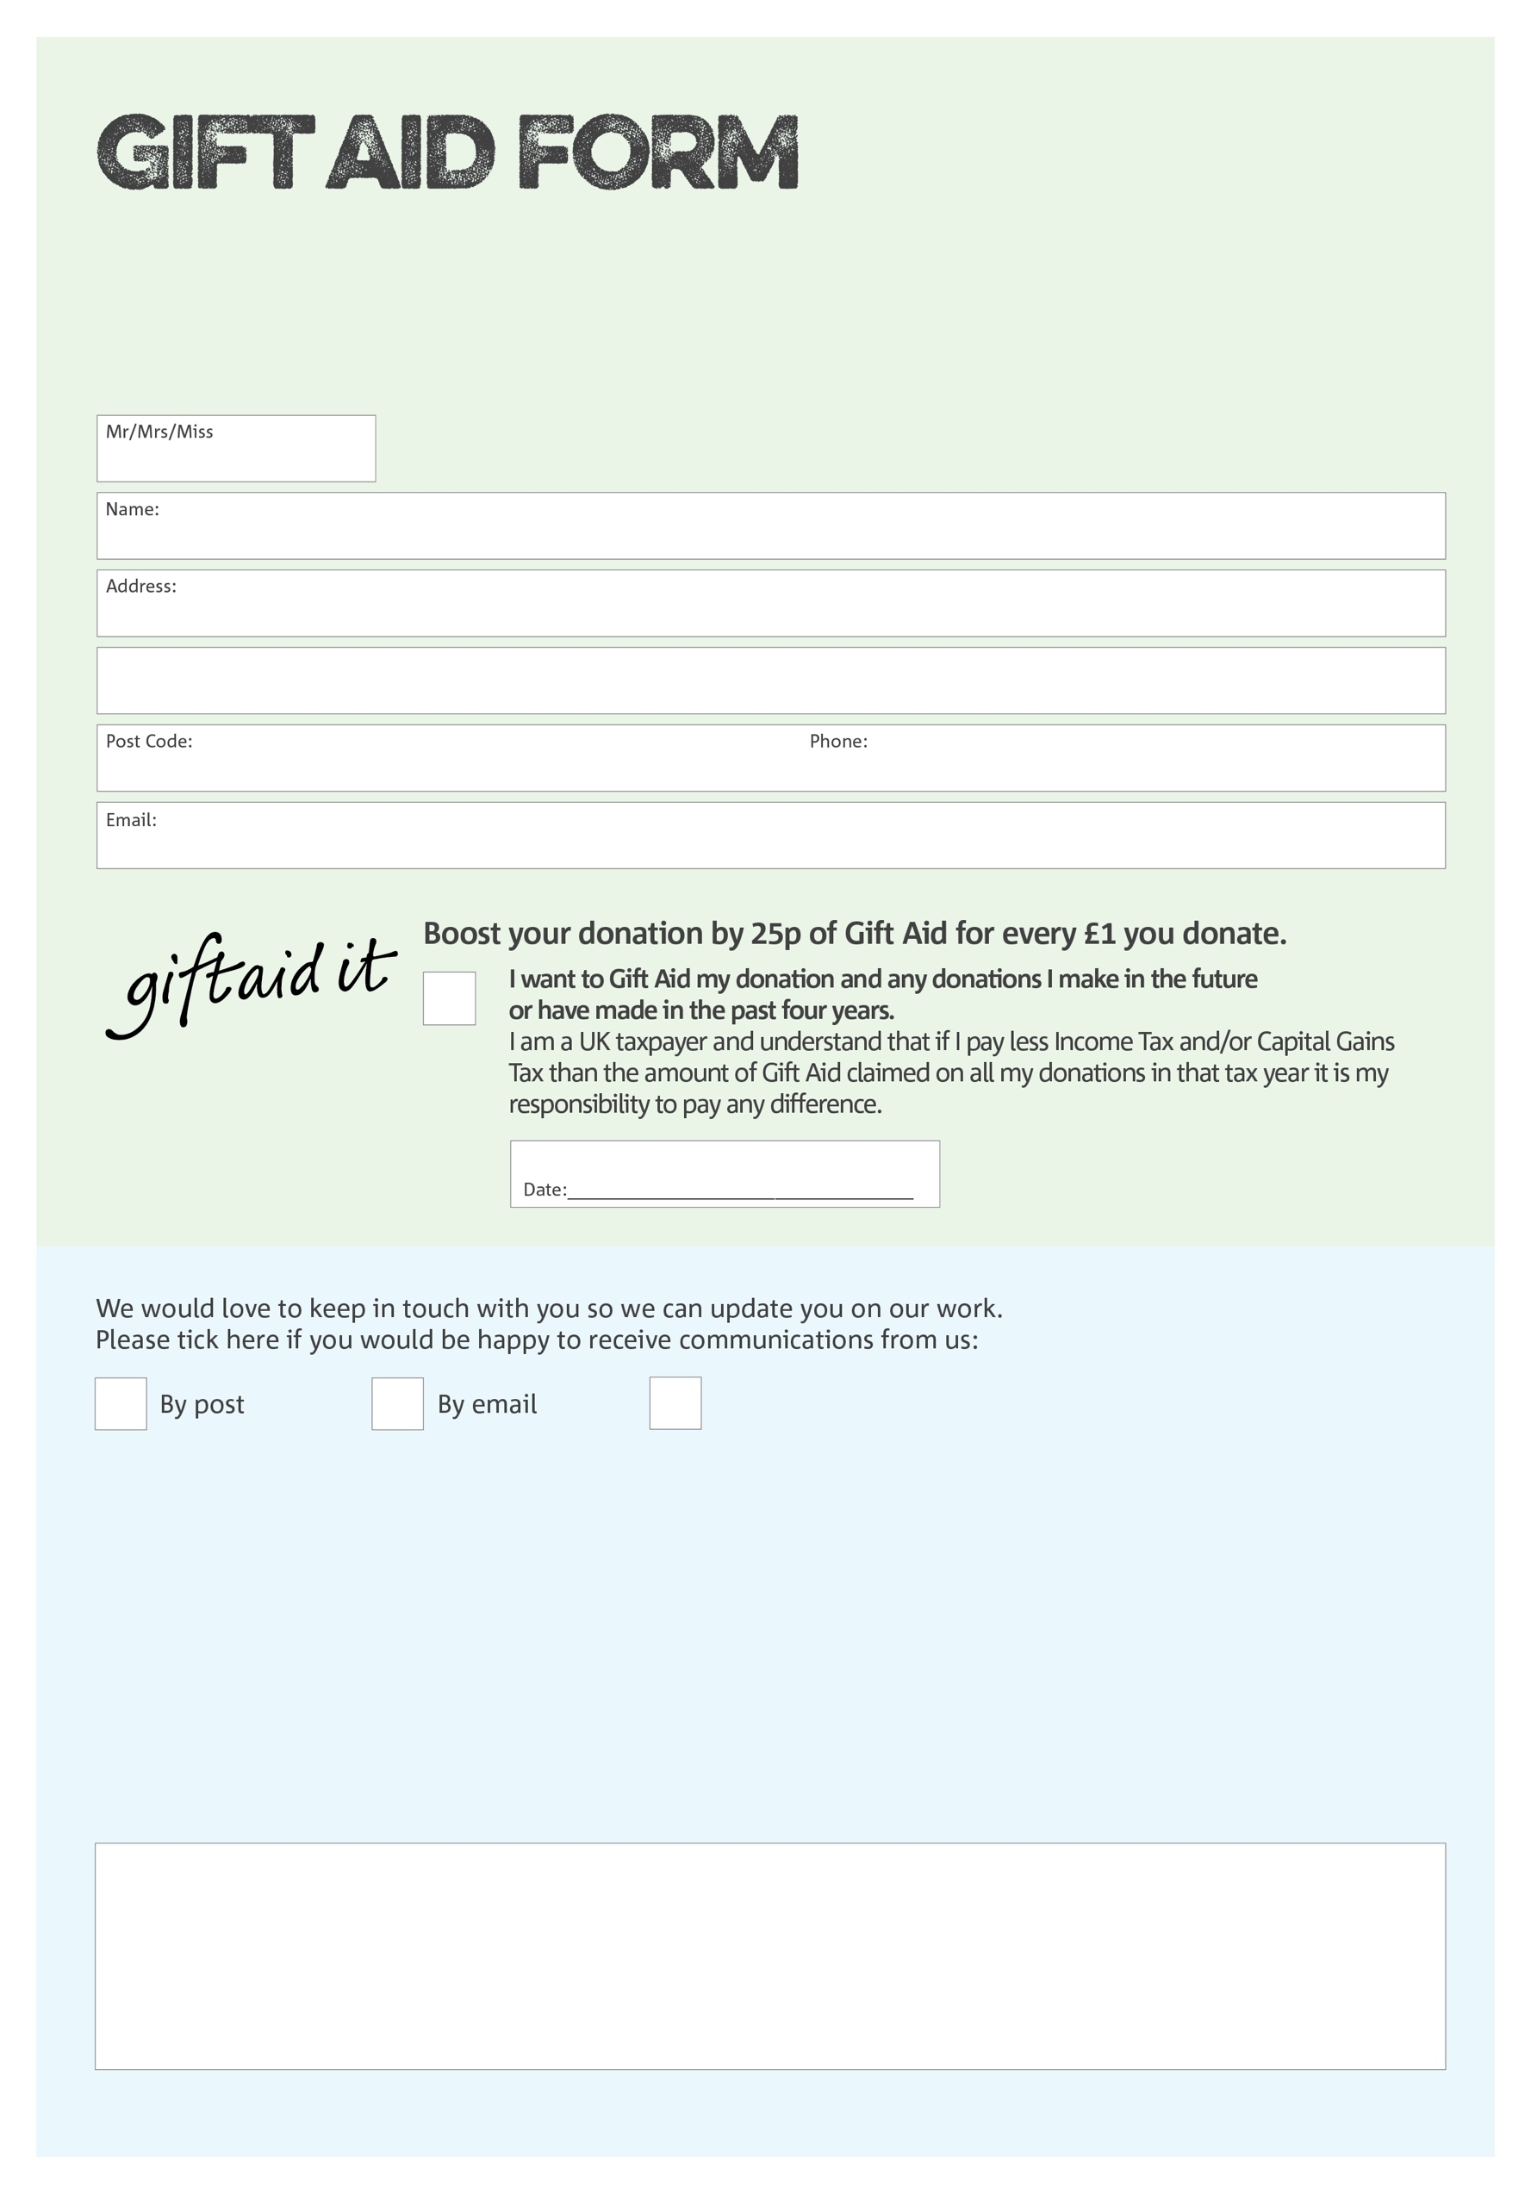

By filling in this form South Gwynedd Foodbank will receive an extra 25p for every £1 you give at no extra cost to you. Thank you!

I do not wish to receive future communications from South Gwynedd Foodbank

You can change your preferences any time by contacting us on 07973914599 or emailing us at

[info@southgwynedd.foodbank.org.uk](mailto:info@southgwynedd.foodbank.org.uk) Please send this form to South Gwynedd Foodbank, Revelation, Park Road, Barmouth, Gwynedd, LL42 1PH

Charity Number 1185190. Registered in England & Wales

**Data protection**

*'South Gwynedd Foodbank is committed to protecting your privacy and will process your personal data in accordance with current Data Protection legislation. South Gwynedd Foodbank collects information to keep in touch with you and supply you with information relating to our work. To unsubscribe from our newsletter, send a message to the email address above with the word unsubscribe in the subject line. A full data privacy statement for financial donors is available from the foodbank on request.’*

We would love to know why you have chosen to donate to South Gwynedd Foodbank. If you would like to share your motivation let us know below: